Leader Formation – Story Gathering – October 2019

As I look back on the week, what continues to resonate with me?
- What work or ways of engaging story caught me?
- What ways of engaging story does my community need?
- What captured my curiosity or my desire to learn more?
- What resonated with where I hope to grow in my role?

Goal-Setting
- How do I make this goal SMART and/or Visual?
- Who will I share it with and how will I be accountable?
- What supports do I need?
- How can my strengths support my growth?

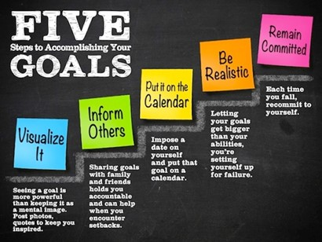

S – Specific

M – Measurable

A – Achievable

R – Rewarding/Rooted/Relevant

T – Time-based

Personal Goal: How do I hope to continue to grow as a person and as a L’Arche member?

Leadership Goal: How do I hope to continue to grow in my role and as leader?

Community / Team Goal: How do I hope to help my team and community to grow?

Bringing the week back to Community
- What tools, language, exercises, framework from the week can bring back to my team, my role, and community?
- What are next steps?
- Who will I work with?
- What ownership and resources do we need to be successful?

Goal
Set it smart: Is it specific, measurable, attainable, rewarding, time-based?

See it: Word, image, quote, inspiration, person/relationship

Share it: Who will I involve?

Support it: What resources do I need?

Strengthen it: How do my strengths support me in meeting the goal?

Goal
Set it smart: Is it specific, measurable, attainable, rewarding, time-based?

See it: Word, image, quote, inspiration, person/relationship

Share it: Who will I involve?

Support it: What resources do I need?

Strengthen it: How do my strengths support me in meeting the goal?

